March 2025

KMC Notes


"Monthly Musings: Moments of Meditation and Meaning"
Transitions are on my mind. I feel like I have been in a state of transition for three months now. Certain parts of this transition have been very special. My family and I feel as though King is home. We have been met and welcomed with love and enjoy being here. It has been remarkable to walk down the sidewalks of town and have conversations with people on those walks. It's been special to have people who don’t know us offer help whenever we ask. My favorite nonchurch memory that has occurred in the short time I have been here is walking in the back door of Stoco at 6:15 on a Wednesday evening and hearing an old-time fiddle tune called “Salt Creek” being taught to children in the local JAM (Junior Appalachian Musicians) program. I love mountain music, so to walk into a new place and unexpectedly hear something so familiar that I love and to know that it is being taught to children here in this new place was heartwarming.
Some new transitions are not bad but, at the same time, not exciting or heartwarming, like being new homeowners. We have always lived in a parsonage, and when stuff would break, the church would call and get it taken care of since we didn't own it. Now, that is on us. I'm very aware that this is nothing new to most people, and it might sound crazy that a 38-year-old is just learning what it is like to set up bills in their name. Nonetheless, it is new. We are so fortunate to be able to pay our bills and, at the same time, its paying bills. It's not good, and it’s not bad; it just is.
Other transitions have had pain attached to them. Our daughter is slowly coming to terms with the fact that the friends she has grown close to won't see her as regularly, and that is causing her pain. Some of the rhythms of life that I had gotten used to and found some joy in have to change because of location and, oddly enough, the shape of the house we now own.
Interestingly, transitions can have all emotions attached to them. Part of me wonders if what dictates the emotion is how much say we have in whether or not we enter a transition time. It seems to me that when we willingly enter into a time of transition, there is the possibility for a more significant amount of positive emotion. Still, when we are thrust into the midst of a transition not of our choosing, whether expected or unexpected, it has a more significant potential to cause negative emotions.
Being in such a transition has caused me to look back and wonder if transitions happen in spurts. Are they always happening? Somewhere in between? Perhaps it's different for each of us, but when looking at my life, I can say transitions were always ongoing; some happened and went instantly, and others took years to conclude. So my musing is this: if we believe God is always around us, can we find God in the places of transition in our lives? What makes God more apparent in times of transition? Is God more evident in one type of transition than others? How do you respond to God amid transitions?
What do you think? I would love to hear your thoughts
Zach




March Birthdays
1- Terri Burton  1- Grayson Finn  2- Susie Grabs  2- Pat McGalliard  2- Debbie Allgood  2- Tyler Shore  4- Kathy Powell  6- Matt Moran  7- Faye Moser  8- Emily Jackson  10- Virginia Southern  11- Matthew Covington  12- Martha Sheaff | 14- Kent Crouch  15- Nan Pulliam  17- Susan Worth  18- Gina Cline  22- Leslie Myers  25- Ashley Donaldson  27- Mallory Redmond  28- Rachel Falls  28- Ethan Smith  28- Eli Thomas  29- Randy Russell  30- Kathy O’Connell

Financials  Offerings received through February 24: $51,929  Budget expenses through February 24: $53,569  2025 monthly contribution for shared Moravian Church Ministries: $4,956.44 per month has been paid through February. | 

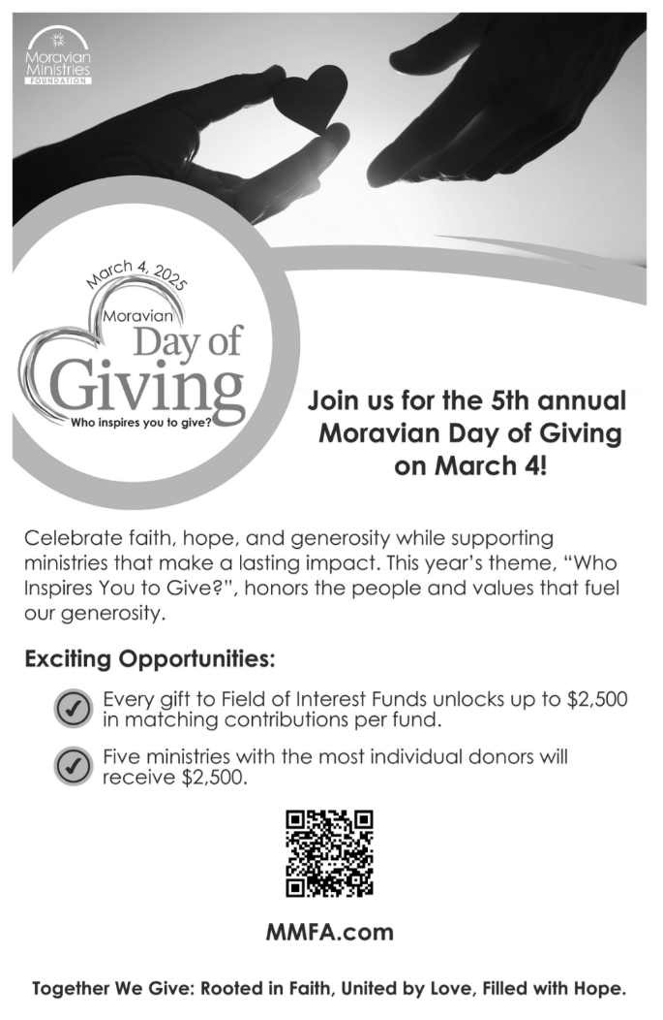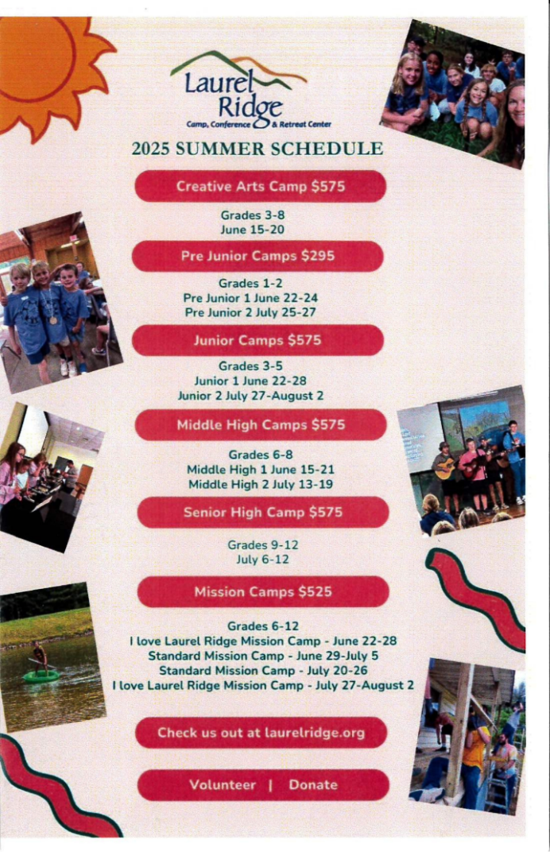

IMPORTANT CAMP SCHOLARSHIP INFORMATION
Our church provides a camp scholarship for our young people who attend church camp at Laurel Ridge. Our church will pay one-half of the camp fees for one camp for any of our members and family members who are active in our congregation. When you register, please use the code “king2025”. If there is a financial need, please let us know because there may be other funding sources for our church camps.

CHURCH SCHOLARSHIPS FOR COLLEGE STUDENTS AND HIGH SCHOOL SENIORS
Our church offers scholarships for members who need financial support for their education.
Our church scholarships are:

Isaac and Mary Ella Booe Scholarship for undergraduate and graduate studies

S. Braxton Brandon Scholarship for undergraduate studies

Jones Family Scholarship for undergraduate and graduate studies

Mark and Heather Johnson Educational Scholarship for high school seniors

For more information about these scholarships, please scan the QR code, go to the church website or stop by the church office.
All applications must be submitted by May 1st.




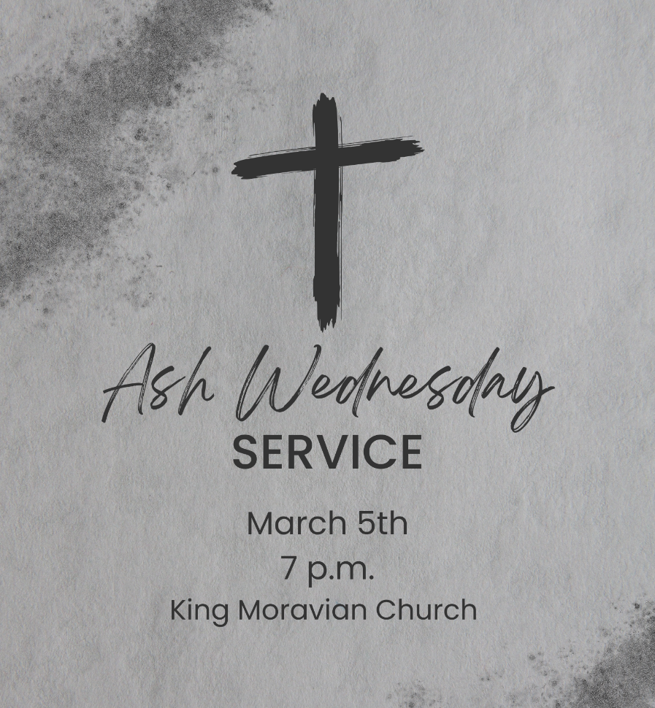
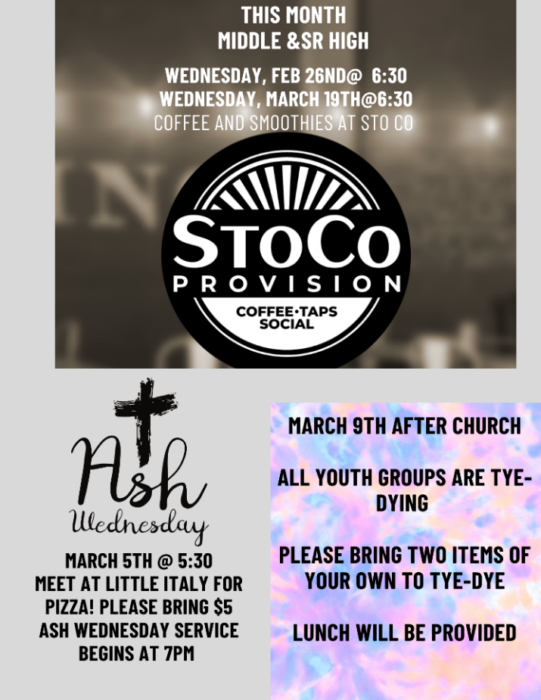
COMING UP!
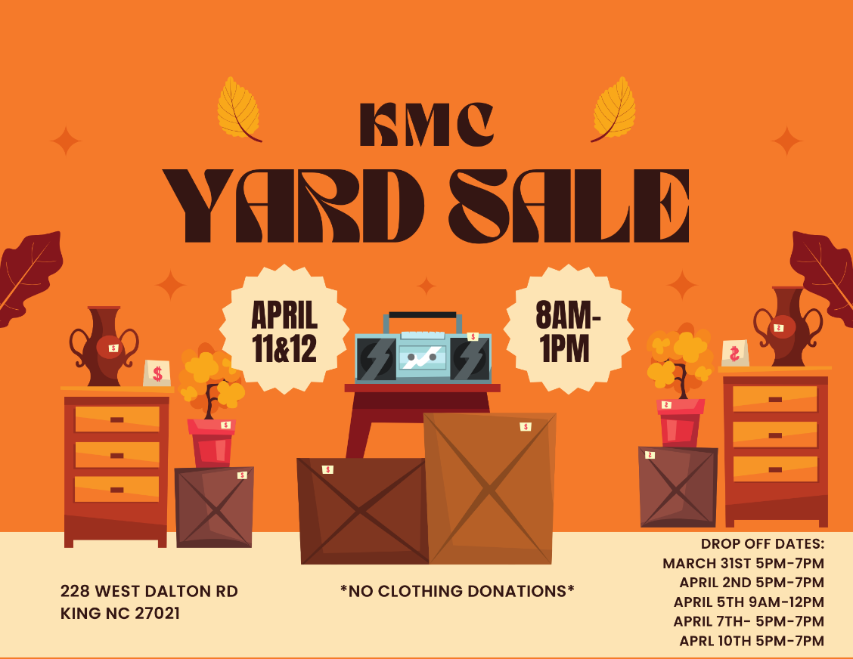
PRESCHOOL THANK YOU!

Thank you to the following people and businesses for their donations to support our Bingo
event. Also thank you to the teachers of King Moravian Preschool for the hours they gave to
help make this event a huge success.

The parents of King Moravian Preschool
Melissa Lomax
Brenna Goldbach
West Stokes High School
Ezra Goldbach Foundation
The Dalton Restaurant
Jacob’s Contracting
Finney Construction
Titan Graphic Works
AERUS of Winston Salem
Cindy McFarland-White Rust Photography
Stokes Tire
Camel City Injector
Zach & Nicole Burick/Lost Shaker of Salt/DS Duggins Welding
As Good As It Gets
Chelsea Work Photography
River Water Tile & Carpentry, LLC
Terry Sechrist- Keller Williams
Coach Gary Nail- Reagan Baseball Camp
Keely Finn- KfinnEsthetics
Terri Fowler- Insight
StoCo
Hometown Whimsey
David’s Honey Backyard Bees
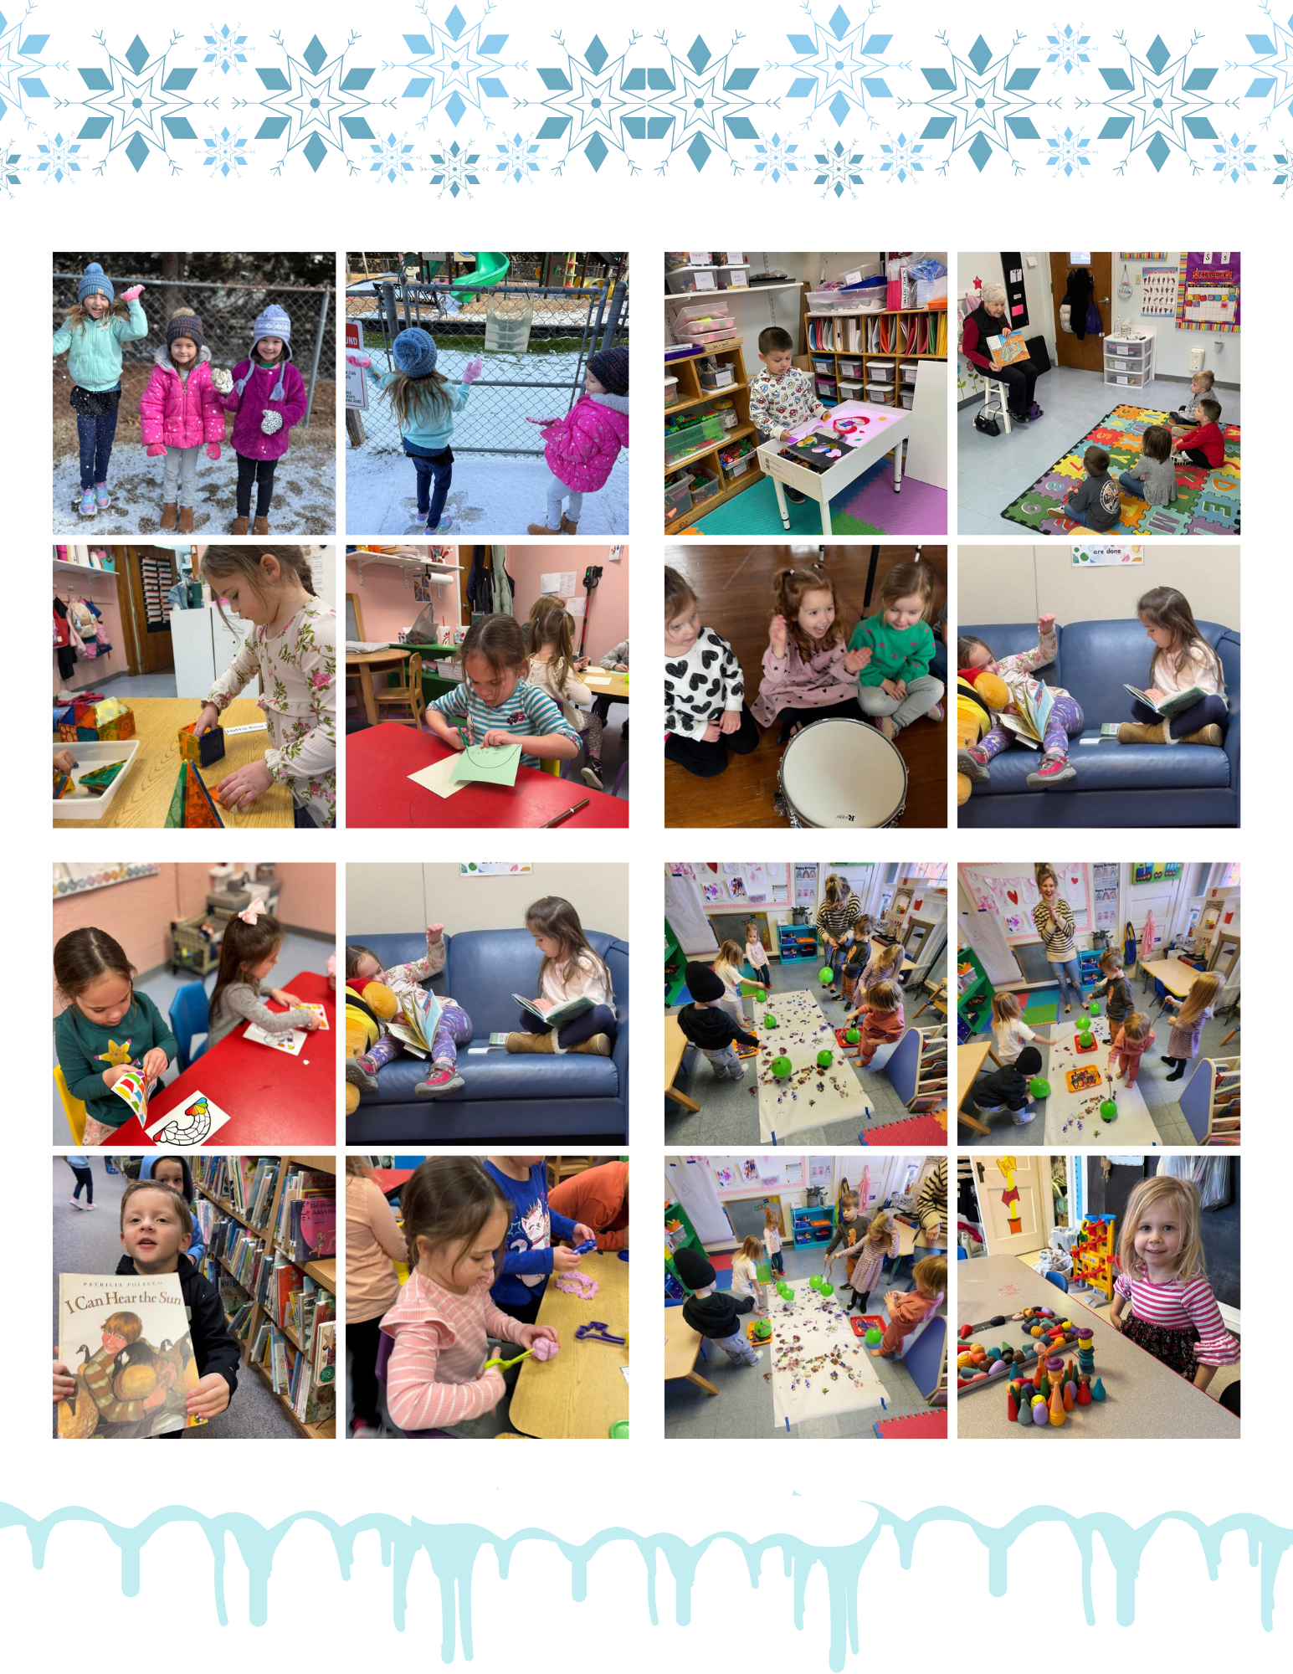
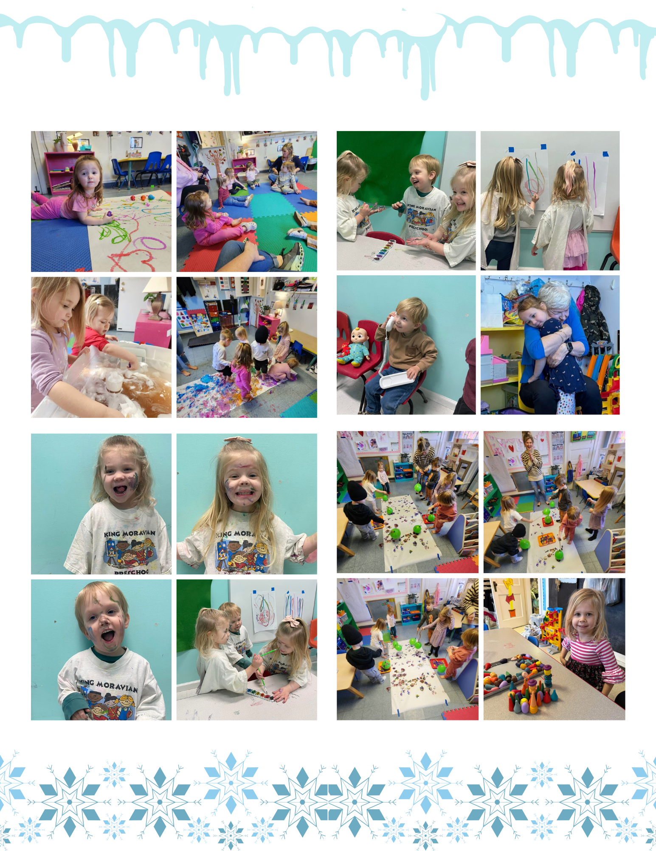
Pray Every Day March 2025
(A list of daily prayer concerns from our Board of World Mission)
- Blessed are they whose transgressions are forgiven, whose sins are covered. Pray for disaster relief workers and Moravian Disaster Response.
- You see, at just the right time, when we were still powerless, Christ died for the ungodly. Pray for Michael and Brenda Brent in Croatia.
- So also grace might reign through righteousness to bring eternal life through Jesus Christ our Lord. Pray for Anna Faircloth with YoungLife.
- For what the law was powerless to do in that it was weakened by the sinful nature, God did by sending his own Son in the likeness of sinful man to be a sin offering. Pray for Charlie and Vicki Brent in Texas.
- And we know that in all things God works for the good of those who love him, who have been called according to his purpose. Pray for the affordable housing initiative sponsored by the Moravian Church Southern Province.
- Neither height nor depth, nor anything else in all creation, will be able to separate us from the love of God that is in Christ Jesus our Lord. Pray for the government leaders in our country.
- I will have mercy on whom I have mercy, and I will have compassion on whom I have compassion. Pray for short-term mission teams.
- Everyone who calls on the name of the Lord will be saved. Pray for Safiatu Braima and Sierra Leonne.
- Oh the depth of the riches of the wisdom and knowledge of God! Pray for seminarians and candidates for ordination.
- I urge you, in view of Gods mercy, to offer your bodies as living sacrifices, holy and pleased to God-this is your spiritual act of worship. Pray for the Moravians in Peru.
- Love must be sincere. Hate what is evil. Cling to what is good. Pray for the Clinica Evangelica Morava in Ahaus, Honduras.
- As surely as I live, says the Lord, every knee will bow before me; every tongue will confess to God. Pray for Moravians in Cuba and the Armando Rusindo Foundation.
- May the God of hope fill you with all joy and peace as you trust in him so that you may overflow with hope by the power of the Holy Spirit. Pray for PEC members, bishops, and other church leaders.
- No eye has seen, no ear has heard, no mind has conceived what God has prepared for those who love him. Pray for Moravians in Honduras and Nicaragua.
- For we are God’s fellow workers; you are God’s field, God’s building. Pray for the Raipur Foster Child Project.
- Now you are the body of Christ, and each one of you is a part of it. Pray for the Teshes in Kenya and Ray of Hope.
- And now these three remain; faith, hope and love. But the greatest of these is love. Pray for Phil and Eunice Raiford in Mexico.
- Be on your guard; stand firm in the faith; be men of courage; be strong. Do everything in love. Pray for refugees all over the world.
- Now the Lord is the Spirit, and where the Spirit of the Lord is, there is freedom. Pray for Adopt-a-Village in Tanzania.
- Therefore, if anyone is in Christ, he is a new creation; the old has gone, the new has come! Pray for Michael and Naomi Woo with OMF International.
- My grace is sufficient for you, for my power is made perfect in weakness. Pray for Joey Yokeley and Fellowship of Christian Athletes.
- There is neither Jew nor Greek, salve nor free, male nor female, for you are all one in Christ Jesus. Pray for the Unity Women’s Desk.
- Therefore, as we have opportunity, let us do good to all people, especially to those who belong to the family of believers. Pray for the Hoffmans in HIV/AIDS ministry.
- But because of his great love for us, God, who is rich in mercy, made us alive with Christ even when we were dead in transgressions-it is by grace you have been saved. Pray for City with Dwellings in Winston Salem, NC.
- Be imitators of God, therefore, as dearly loved children. Pray for Kevin and Charity in the Middle East.
- Be completely humble and gentle; be patient, bearing with one another in love. Pray for the Harrisons with Greek Intervarsity.
- Serve wholeheartedly, as if you were serving the Lord, not men, because you know that the Lord will reward everyone for whatever good he does. Pray for Brian and Heather Marx with Mission Aviation Fellowship.
- But whatever was to my profit I now consider loss for the sake of Christ. Pray for Alan and DeeDee Iobst in France.
- Rejoice in the Lord always. I will say it again: Rejoice! Pray for Annie B Missions and Star Mountain.
- I can do everything through him who gives me strength. Pray for the Board of World Mission and their mission partners.
- Since then you have been raised with Christ, set your hearts on things above, where Christ is seated at the right hand of God. Pray for Estamos Unidos Moravian Ministry.

KMC Notes
March 2025
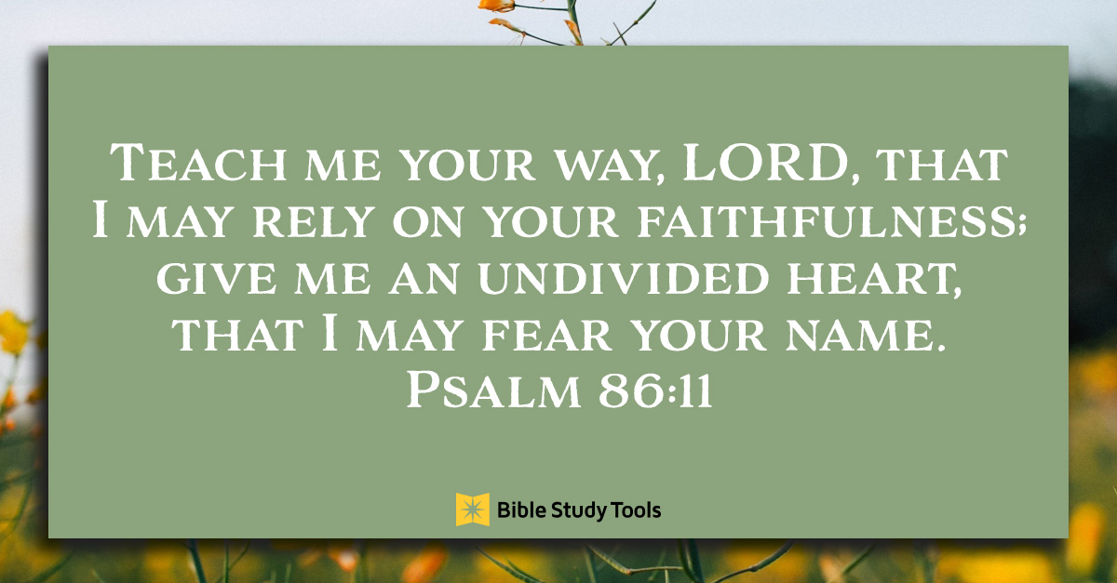

King Moravian Church
228 West Dalton Rd.
King, NC 27021

